**SHORT C V**

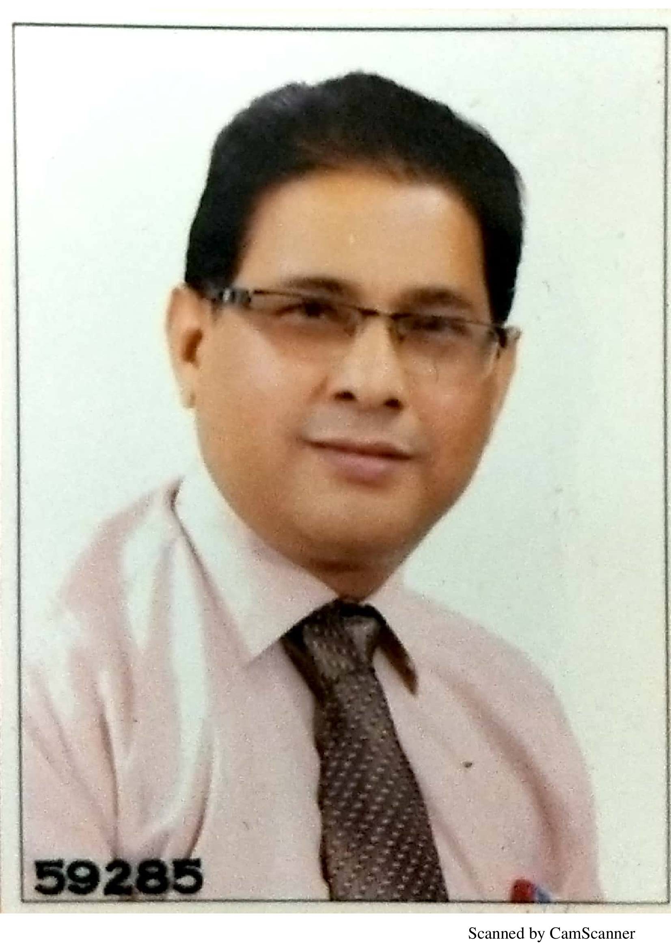

**Name:**                              Dr. Pooran Chand

**Contact No.** 09415173419, Email- [dr.pooran_chand@yahoo.com](mailto:dr.pooran_chand@yahoo.com), dr.pooran11@gmail.com

**Academic Qualification**  MDS (Prosthodontics), MBA

**Present designation:** Currently working as ***Professor and Head***,

Department of Prosthodontics and crown & bridge,

Faculty of Dental Sciences, King George Medical University, Lucknow, UP.

**Memberships of academic and specialty associations: 11**

1. Member Indian Dental Association, Lucknow Branch - 9158
2. Life Member Indian Prosthodontic Society - OL 634
3. Life Member Indian Society of Prosthodontics-Restorative-Periodontics - LM 277
4. Life Member of the Academy of Oral Implantology - AC/L1585/UP.
5. Life member of The Indian Association of Forensic Odontology — LM 151.
6. Life member of Indian Society of Dental Research- LM-741
7. International College of Prosthodontists-2015
8. Executive Committee Member - Maxillofacial society of India
9. Life member of International Academy of Medical Sciences 2016
10. Life member Indian Science Congress Association 2018
11. Executive Council Member- Indian Prosthodontic Society

**Post held in academic association: 5**

1. EC Member Indian Prosthodontic Society, 2019-21.
2. Secretary cum Treasurer, IPS UP State Branch - 2015 to 2020.
3. President, Indian Dental Association, Lucknow Branch-2013
4. Elected Vice President Indian Dental Association, Lucknow Branch 2010 & 2011.
5. Secretary, Indian Dental Association, Gorakhpur Branch.

**Editorial board/reviewer board member of journals: 6**

1. Member Editorial Advisory Board - National Journal of Maxillofacial Surgery
2. Member of Editorial Board - Journal of Indian Dental Association, Uttrakhand
3. Member of Specialty Editorial Board - Indian Journal of Dental Specialties and Research
4. Member of Reviewer Board- Journal of Academy of Oral Implantology
5. Member of Editorial Board- Scientific Dental Research Journal (CDRJ)-2019
6. Member of Editorial Board- Innovative Publications

**Patent Filed: 6**

1. Patent file publication no.: 201611034118 dated 5/10/2016

2. Patent file publication no.:201811027699 dated 24/07/2018

3. Patent file publication no.: 201811043121 dated 16/11/2018

4. Patent file publication no.: 202011005806 dated 11.02.2020

5. Patent file publication no.: 202011024309 dated 10.06.2020

6. Patent file publication no.:202011028786 dated 07.07.2020

**COPYRIGHT:**

1. PNSBP Classification of Ocular Defects and Prosthesis: 2928/2019-CO/
2. Classification of Obstructive Sleep Apnea along with treatment modalities based on Oral examination : L-102222/2021
3. Prosthetic treatment based classification of Auricular defects- L-100607/2021
4. Classification of tripodization methods- L-100445/2021
5. Classification of salivary reservoir- L-100401/2021

**TRADEMARK:**  Application no 4539896 dated 22/06/2020

**BOOK WRITING**

1. KGMU Book of Clinical Cases in dental Sciences.

2. Impact of Different Prosthodontic Treatment Modalities on Nutritional Parameters of Elderly Patients. Journal of Prosthodontic Compete and Removable Denture, Blakcwell Publication 2018:1:66-73

**PUBLICATIONS:** International: 32; National: 54

**Fellowship awarded:**

1. Fellow of International College of Dentists, USA.
2. Fellow of Pierre Fauchard Academy ,U.S.A.(India Section)
3. Fellow of International Academy of Medical Sciences
4. Fellow of Academy of Dentistry International (USA)
5. Fellow of Indian Society of Dental Research (ISDR)

**OTHER AWARDS:**

1. Seva Bhushan Samman by Seva Bharti through Maha Maheem honorable governor Shri Ram Naik., 2016
2. Awadh Gaurav award by India Watch TV, 14 Jan, 2016.
3. Indian Health Professional Award (Outstanding dentists of the year) by Smile Nation, 2016.
4. Vishisht Seva Samman by Sahuji Maharaj Smriti Manch, 2017.
5. Utkristh Samajik Seva Samman by Balaji Gramyudyogya Seva Samiti, 3rd Aug,2018
6. “**Vigyaan Ratna Samman”** Award of Council of Science and Technology, UP by Honorable Chief Minister of Uttar Pradesh for the year 2015-16.
7. Seva Bhushan Samman by Honb. Governor Uttar Pradesh.
8. Best speaker of the year in Dentistry 2019 by Smile Nation (Indian Health Professional Award).

**(Dr. Pooran Chand)**

**Professor and Head**

Department of Prosthodontics

King George Medical University Lucknow,